1. Go to [www.python.org](http://www.python.org)
2. **Hover mouse** over **Downloads** and click on the button under **Download for Windows**

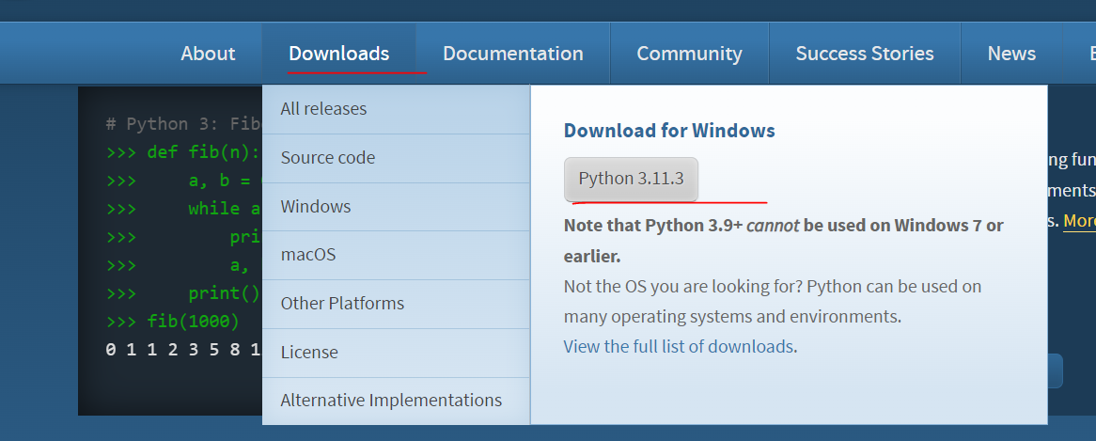

1. Run the downloaded exe file
2. **Select “Add python.exe to PATH”**

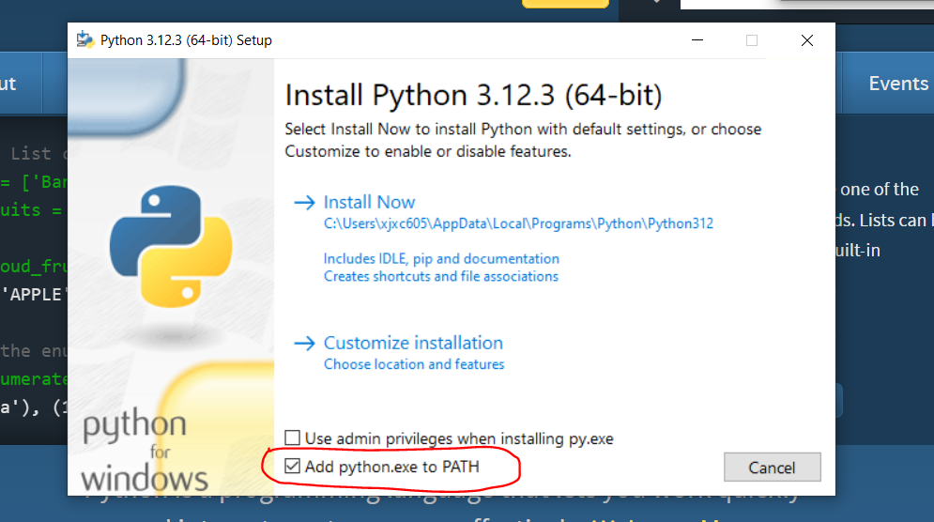

1. Click **Install Now**
2. Click **Close**
3. Download C++ Build Tools from [Microsoft C++ Build Tools - Visual Studio](https://visualstudio.microsoft.com/visual-cpp-build-tools/)

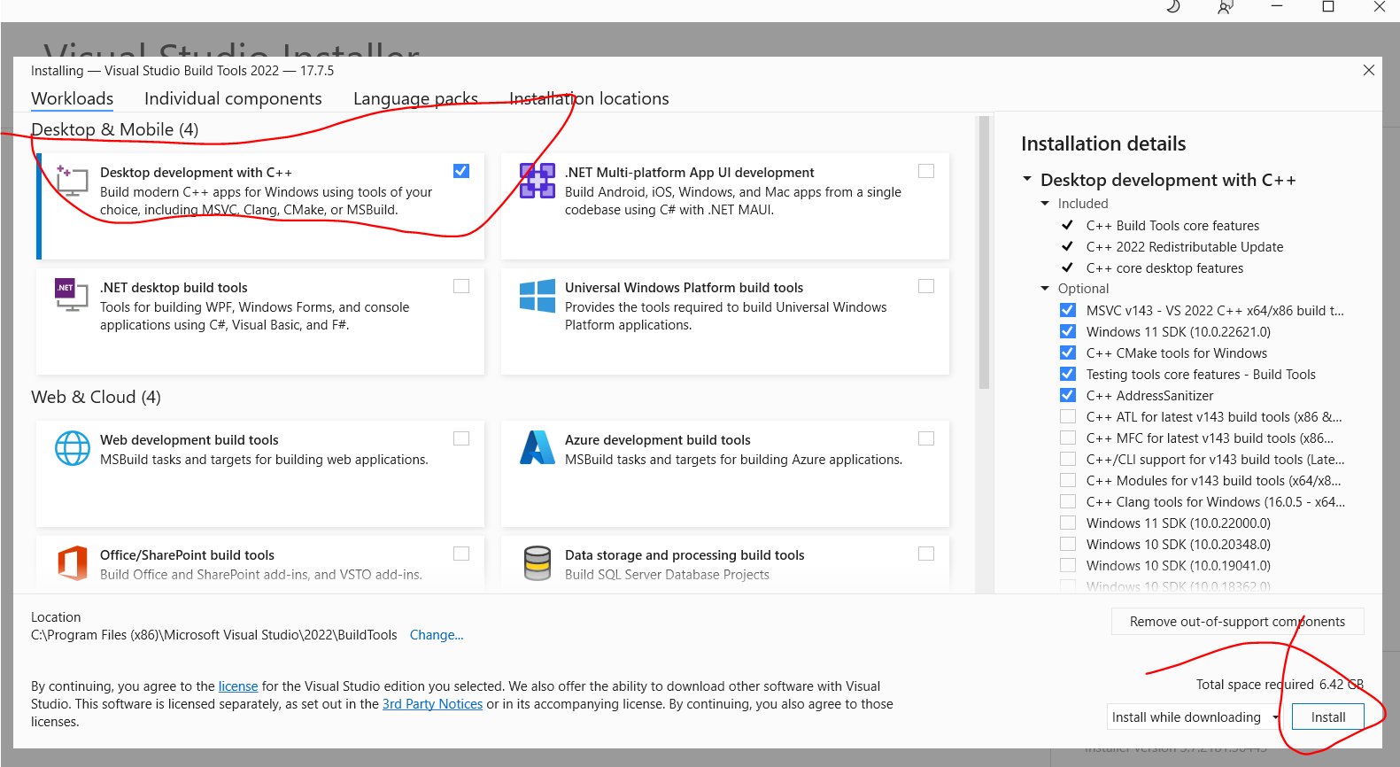

1. Press the WINDOWS KEY and search “CMD” and open command prompt

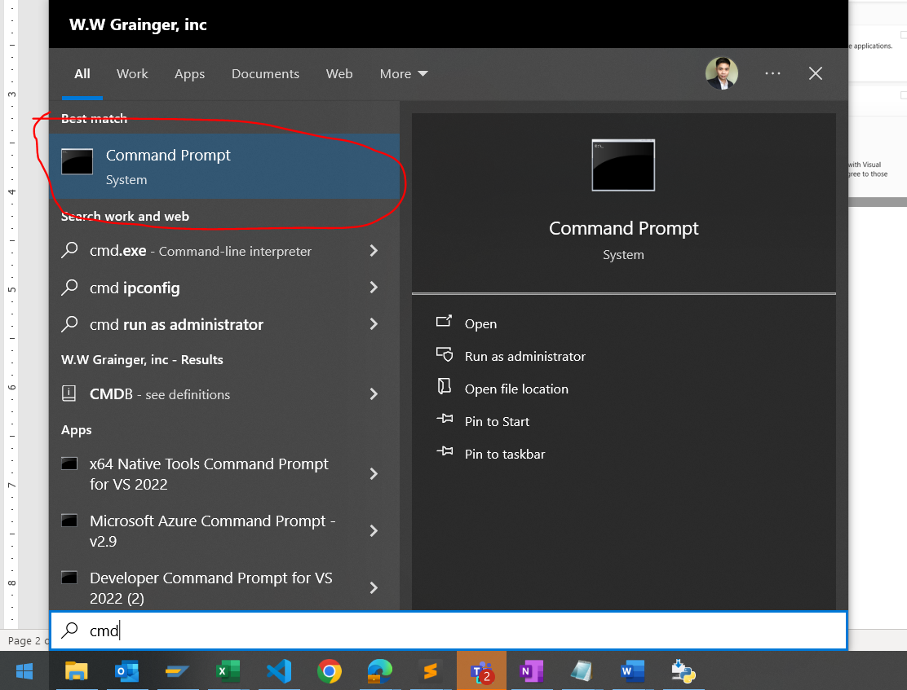

1. Type **pip install snowflake-connector-python** and press ENTER

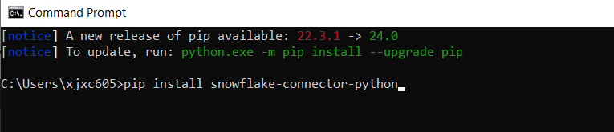

1. REPEAT STEP 9 FOR THE FOLLOWING:

**pip install pandas**

**pip install openpyxl**

**pip install requests**

**pip install python-certifi-win32**

**pip install pyodbc**

**pip install pyqt6**